# Proposition scientific project: Acoustic levitation

## What is it?

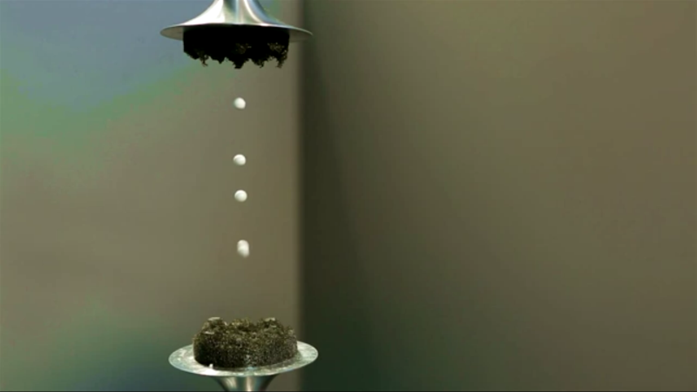Acoustic levitation is the term for suspending little droplets of fluid or very light objects like Styrofoam using only soundwaves.

## How does it work?

To understand how it works, we first need to understand waves, more precisely standing waves.  
A standing wave is best imagined with a rope, connected to a fixed point (like a wall) on one end and held by a person on the other end. When the person sends a wave through the rope, it will propagate until the wall. At that point the wall will send the same wave (a wave with the same frequence) through the rope, going the opposite direction.   
These two waves propagating through the same rope will undergo a physical phenomenon called ‘Interference’. This phenomenon is caused by two waves with the same frequency ‘colliding’ on a shared medium. When the waves are in phase (both going up), they will undergo ‘constructive interference’ and double their amplitude. This is called an ‘antinode’.  
When they are in opposite phase (one going up while the other is going down) they will undergo ‘destructive interference’, cancelling each other out, resulting in an amplitude of 0 or a stationary point on the rope. This is called a ‘node’.

As sound is a wave propagating through air, they can also interfere with each other. The difference with the aforementioned example is that you cannot connect air to a fixed point like the wall. Therefore we will take two sound generators placed directly opposite of each other. They will both send a soundwave of the same frequency and at the nodes of that frequency, the air will be compressed so hard that it can suspend very light objects or droplets of fluid.

## Feasibility

In terms of money this project is very possible, as we basically only need a couple of supersonic transducers which cost about a dollar each, a frame to mount them on which can be made out of simple cardboard or wood and an Arduino to control the transducers, which is made available by the University.

In terms of difficulty it depends on how precise the transducers have to be placed and how difficult it is to control them with Arduino, which is hard to say on this point.